7th and 8th Grade
Science
Winter Break

Jennings Junior High School
Science Department

Name: ______________________ Class: _________________ Date: _________

8th Grade Science

Multiple Choice
Identify the choice that best completes the statement or answers the question.

____ 1. Which of the following describes an object moving in a circle steadily?

A. change in speed only B. change in direction only
C. no change in speed or direction
D. change in speed and change in direction
____ 2. Michael is whirling a can on a string above his head at a constant speed. The following
picture shows the motion of the can around his hand.

Which statement best describes what happens to the can?

A. The can is accelerating because it is changing direction.
B. The can is accelerating because it moves faster and faster. C. The can accelerates because it moves slower and slower.
D. The can does not change speeds, so there is no acceleration.

1

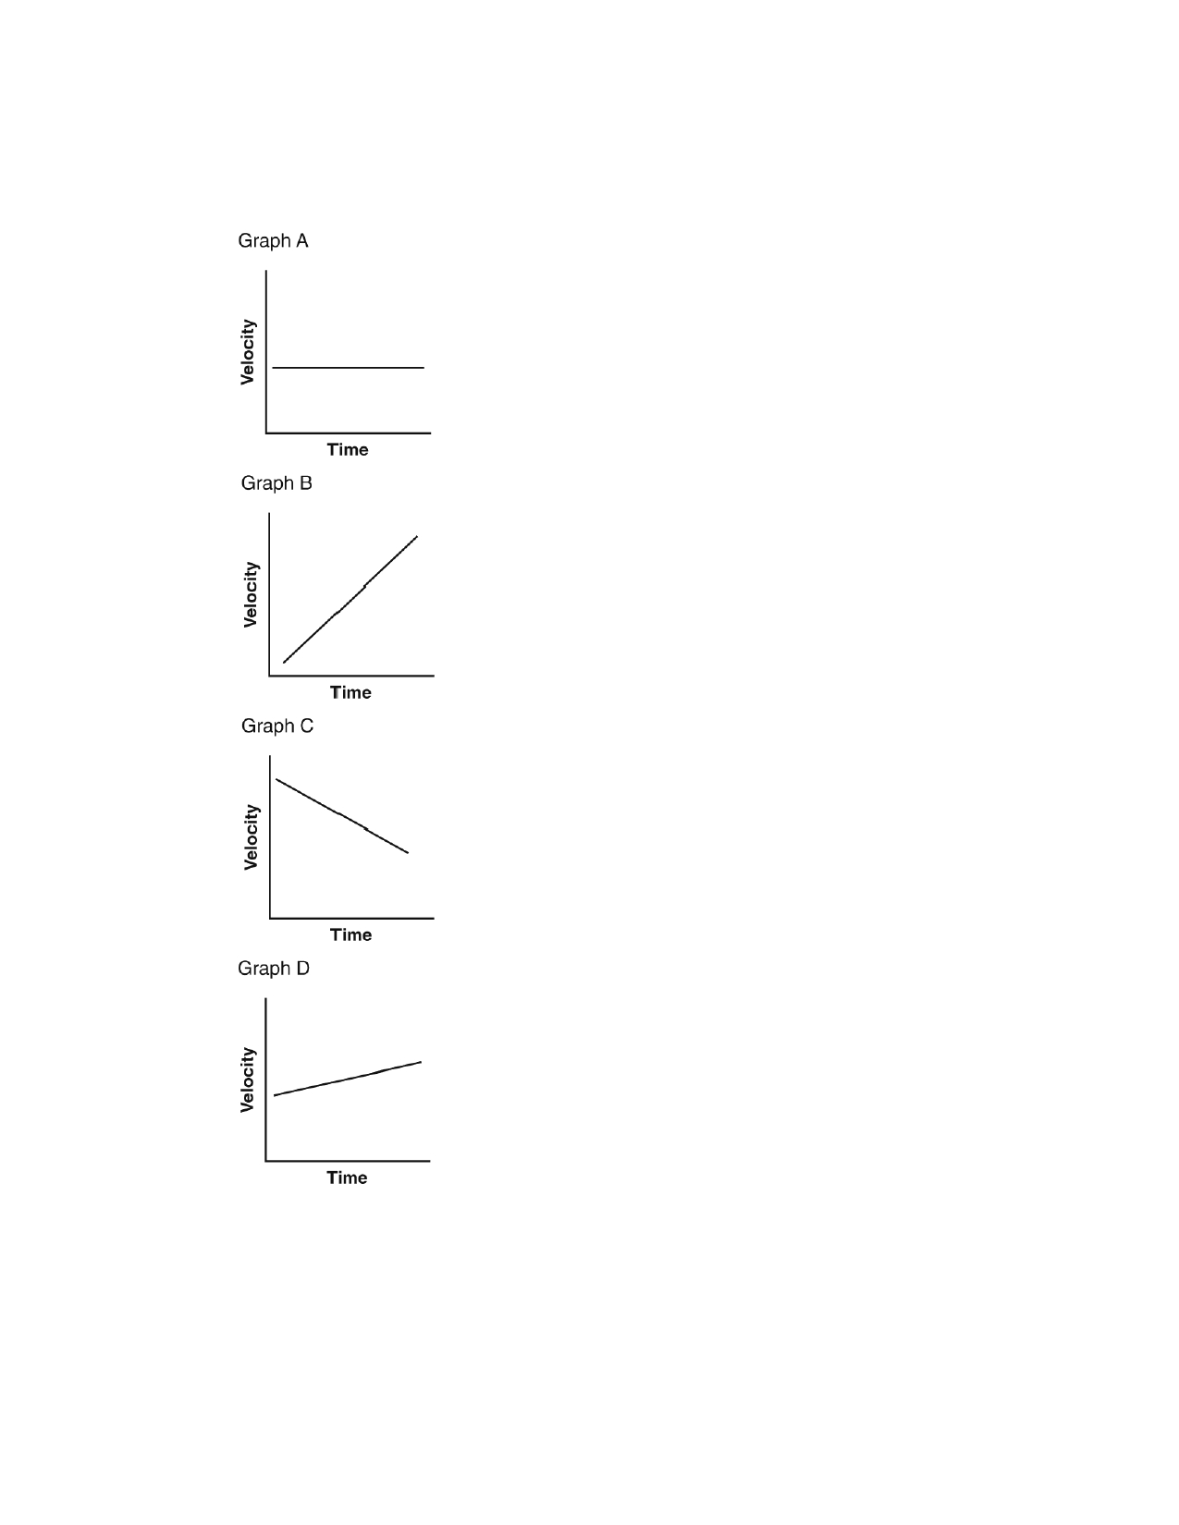
Name: ______________________ ID: A

____ 3. The graphs show the motion of cars on a straight road. Which graph most likely shows
the velocity of a car approaching a red stoplight?

A.

B.

C.

D.

2

Name: ______________________ ID: A

____ 4. The diagram below shows a spring that has been pushed down.

Which form of potential energy does the spring have?

A. chemical B. elastic
C. electrical
D. gravitational

3

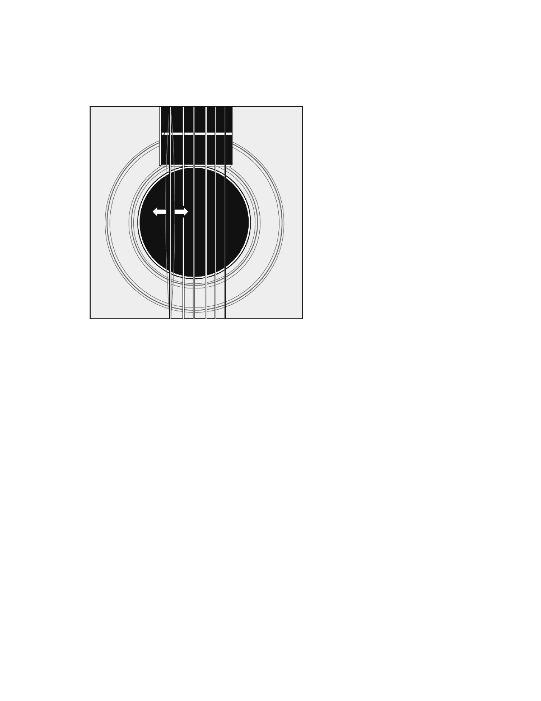
Name: ______________________ ID: A

____ 5. Damon is a musician playing in a band. At the end of a song, he plucks a single guitar
string. The string moves rapidly back and forth as shown in the figure below.

Which of these statements explains what happens to the kinetic energy of the moving
string?

A. B. C. D.

The kinetic energy is changed into potential energy and stored.
The kinetic energy is converted to sound energy and thermal energy. The kinetic energy is destroyed until no energy remains.
Some of the energy is converted to sound energy, but the rest is destroyed.

4

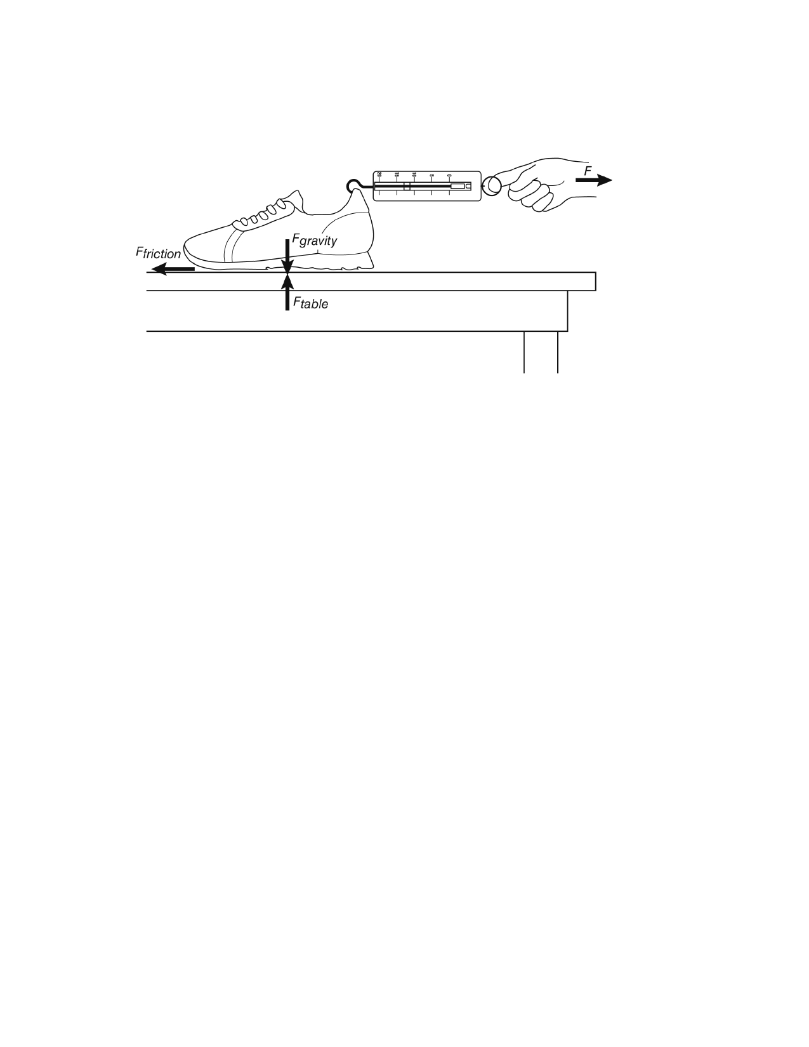
Name: ______________________ ID: A

____ 6. The following picture shows forces acting on a sneaker. Suppose that the sneaker is
moving toward the spring scale.

In which direction is the sum of all the forces (the net force) acting?

A. The net force is acting in an upward direction. B. The net force is acting in a downward direction. C. The net force is acting to the left. D. The net force is acting to the right.
____ 7. Which of the following describes the result of a force acting on an object?

A. The force changes the mass of the object. B. The force does not cause a change in the object. C. The force transfers energy to or from the object.
D. The force increases or decreases the weight of the object.

5

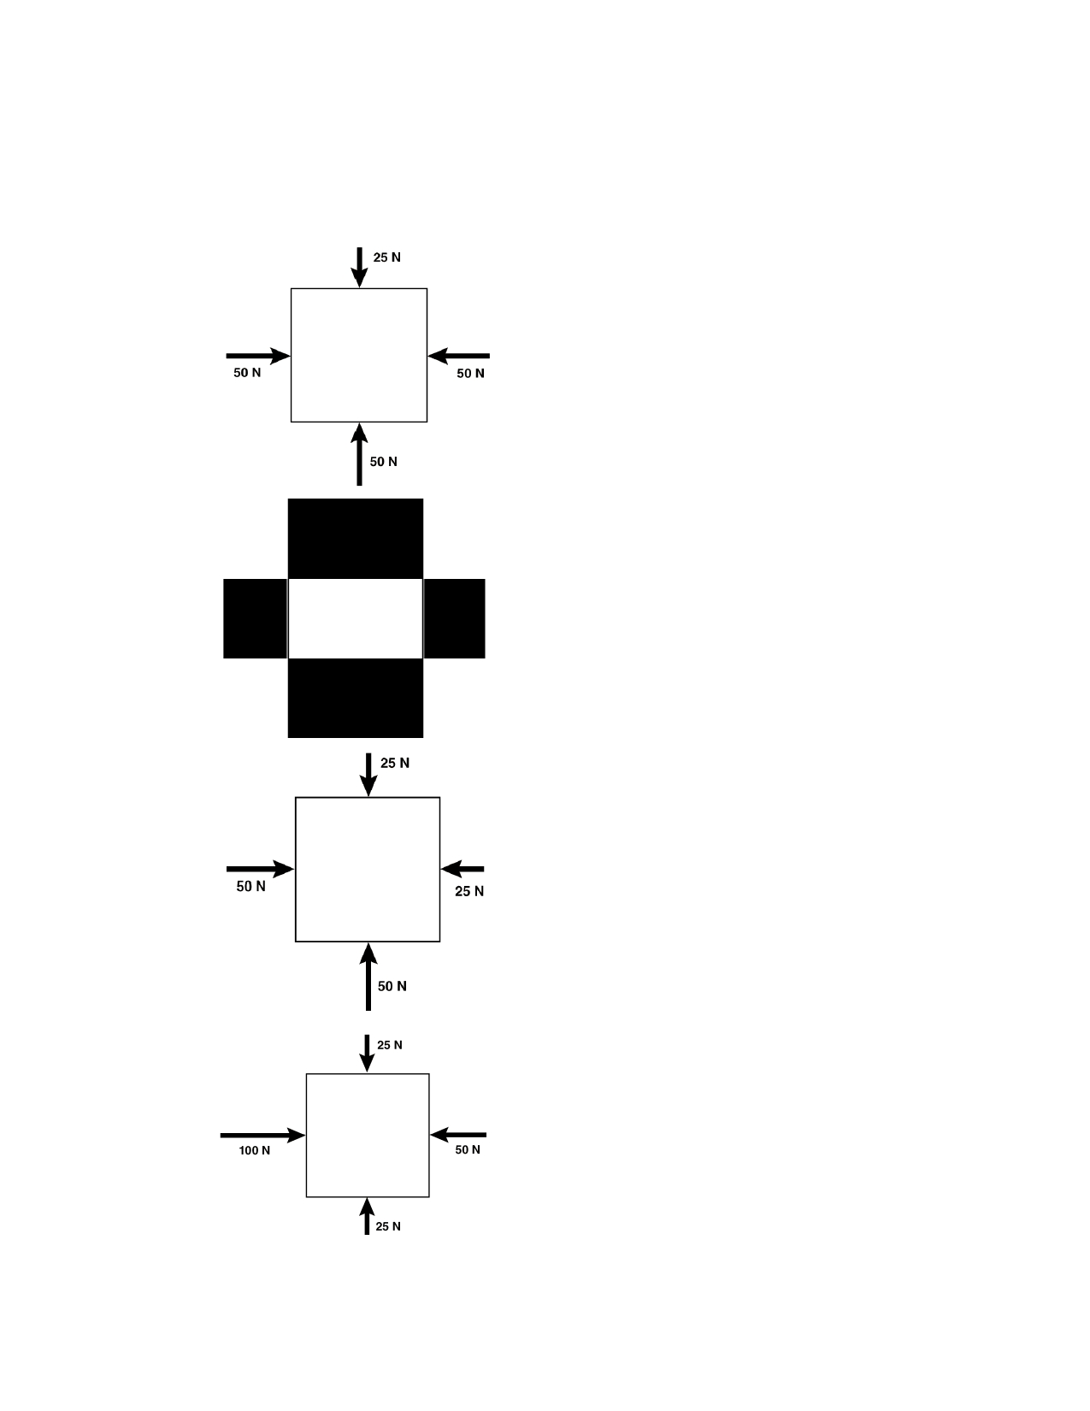
Name: ______________________ ID: A

____ 8. A group of four students used spring scales to measure the forces applied to the sides
of a box. During each trial, they changed the forces, observed the results, and sketched a diagram showing the applied forces. Which picture shows the box with no net force?

A.

B.

C.

D.

6

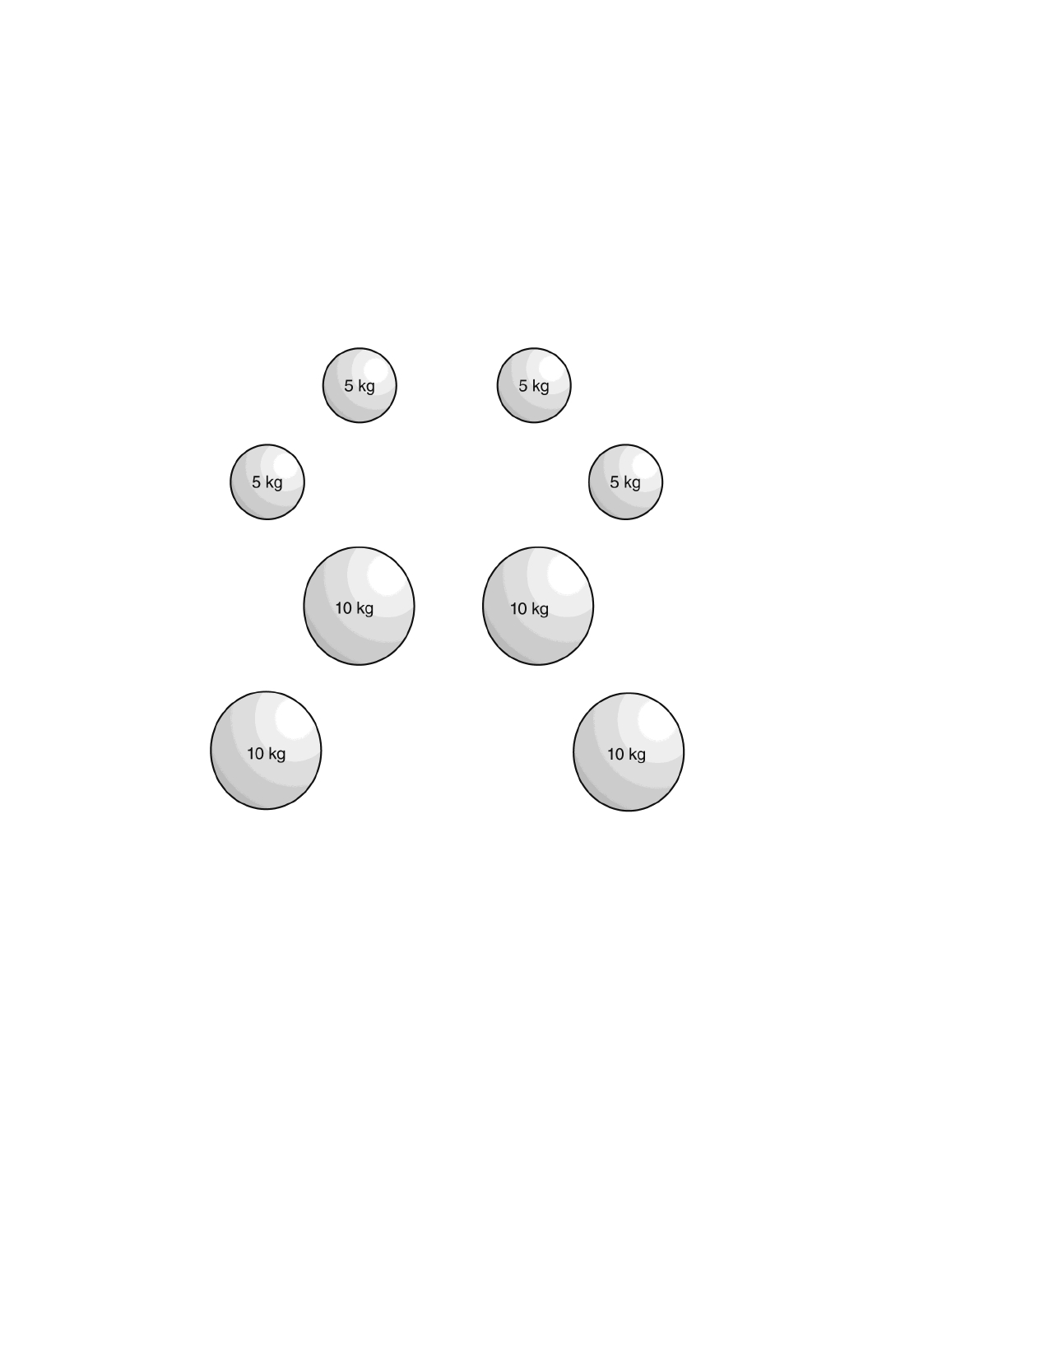
Name: ______________________ ID: A

____

9. Which object has the greatest force of gravity acting on it?
A. a 5-g object that is flat
B. a 15-g object that is flat
C. a 5-g object that is round
D. a 10-g object that is round

____ 10. The objects shown in the following diagrams have different masses and are different
distances apart. Which diagram shows the two objects that have the greatest force of
gravity acting between them?

A.

B.

C.

D.

7

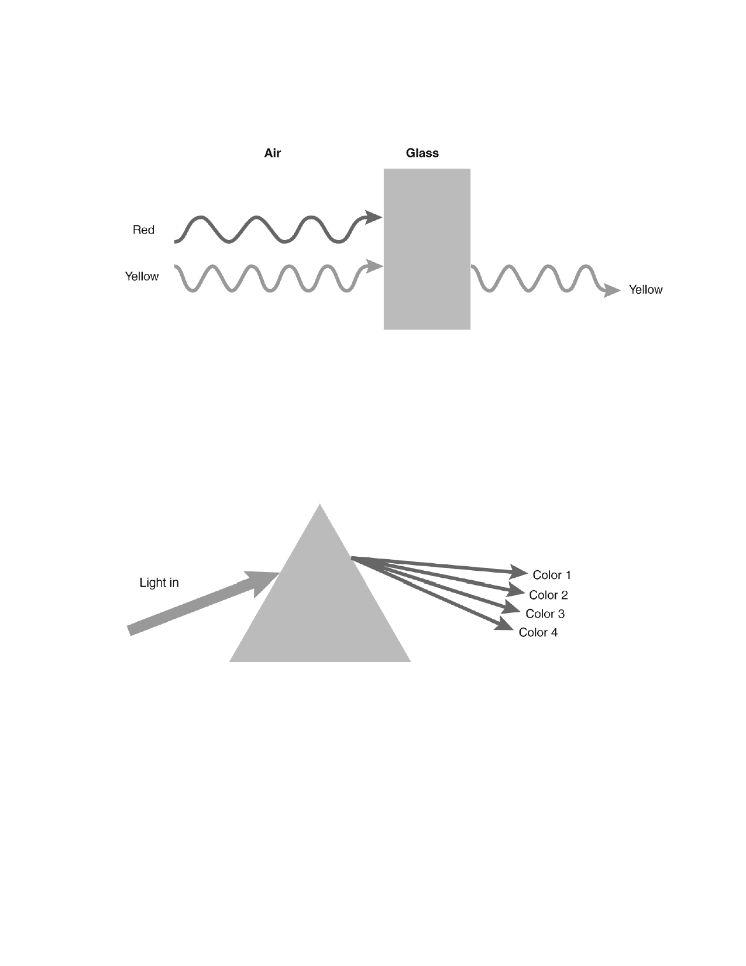
Name: ______________________ ID: A

____ 11. Red light waves and yellow light waves travel through air and strike the surface of glass.
Only the yellow light waves travel through the glass as shown in the figure below.

What color must the glass be?
A. orange B. purple
C. red
D. yellow
____ 12. Feng shines a thin beam of light onto a prism. The light contains wavelengths of red,
blue, green, and yellow light. The diagram below shows how the four colors of light exit the prism at different angles.

Which of the wavelengths is color 1?
A. red light
B. blue light
C. green light D. yellow light

8

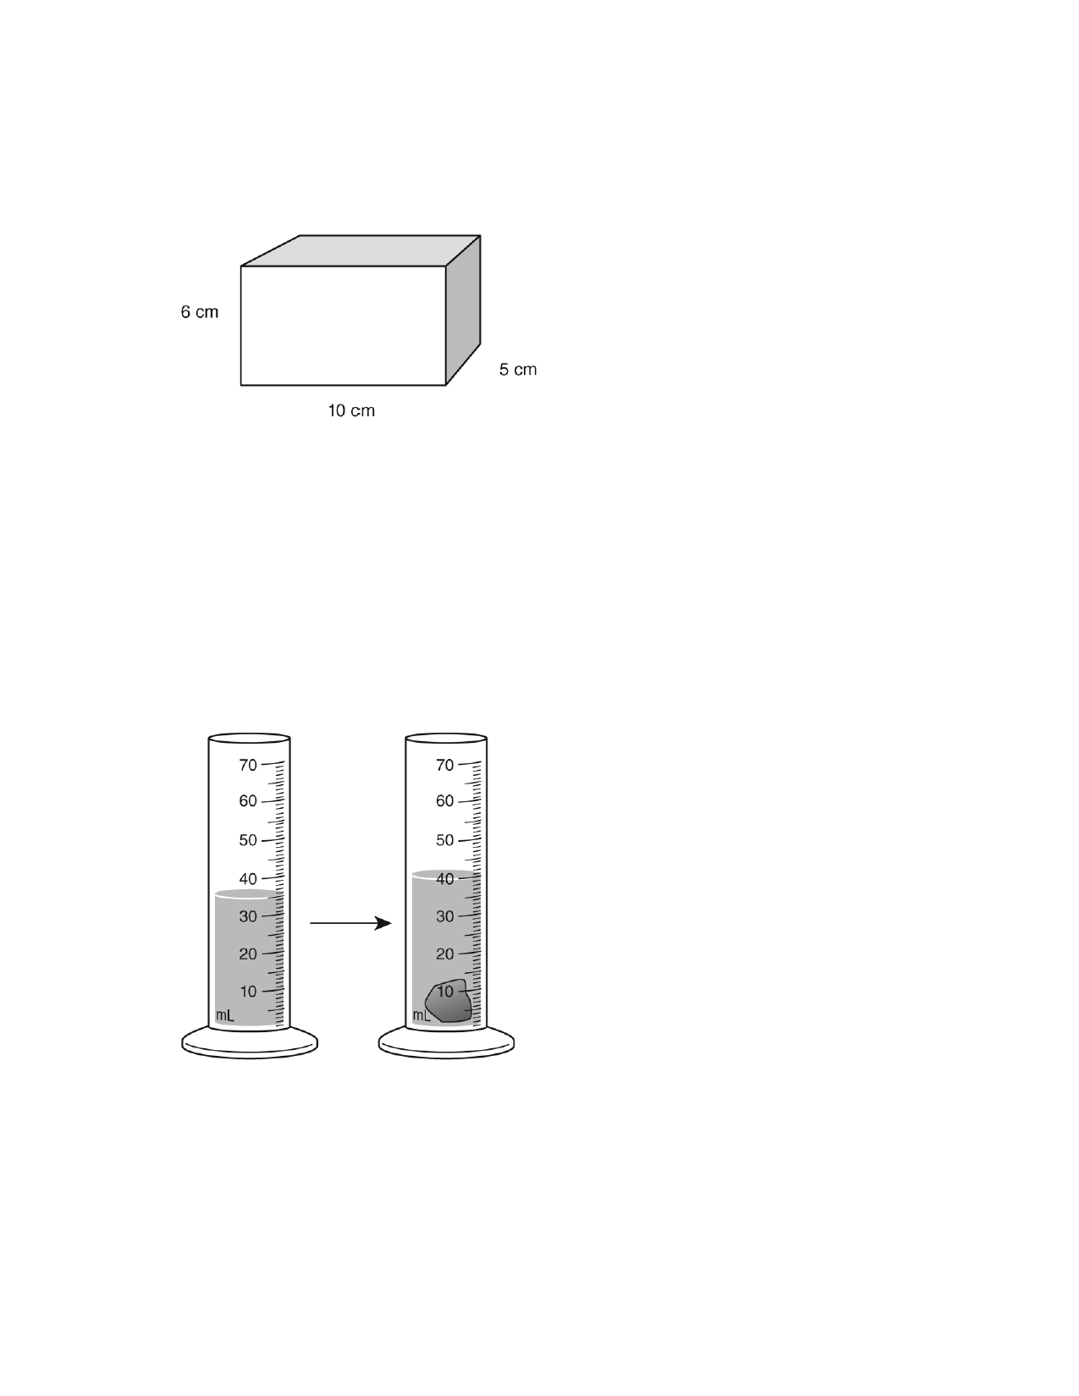
Name: ______________________ ID: A

____ 13. Density is the ratio of mass to volume. This block is made of a material that has a
density of 2 g/cm3.

What is the mass of this block, if its volume is equal to its length times width times
height?

A. 150 g B. 300 g C. 600 g
D. 6,000 g
____ 14. Julio measured the mass of a small rock as 11.0 grams. Then he measured the
volume of the rock as shown in the illustration below.

What is the density of Julio's rock?

A. 1.1 g/cm3 B. 2.2 g/cm3
C. 5 g/cm3 D. 11 g/cm3

9

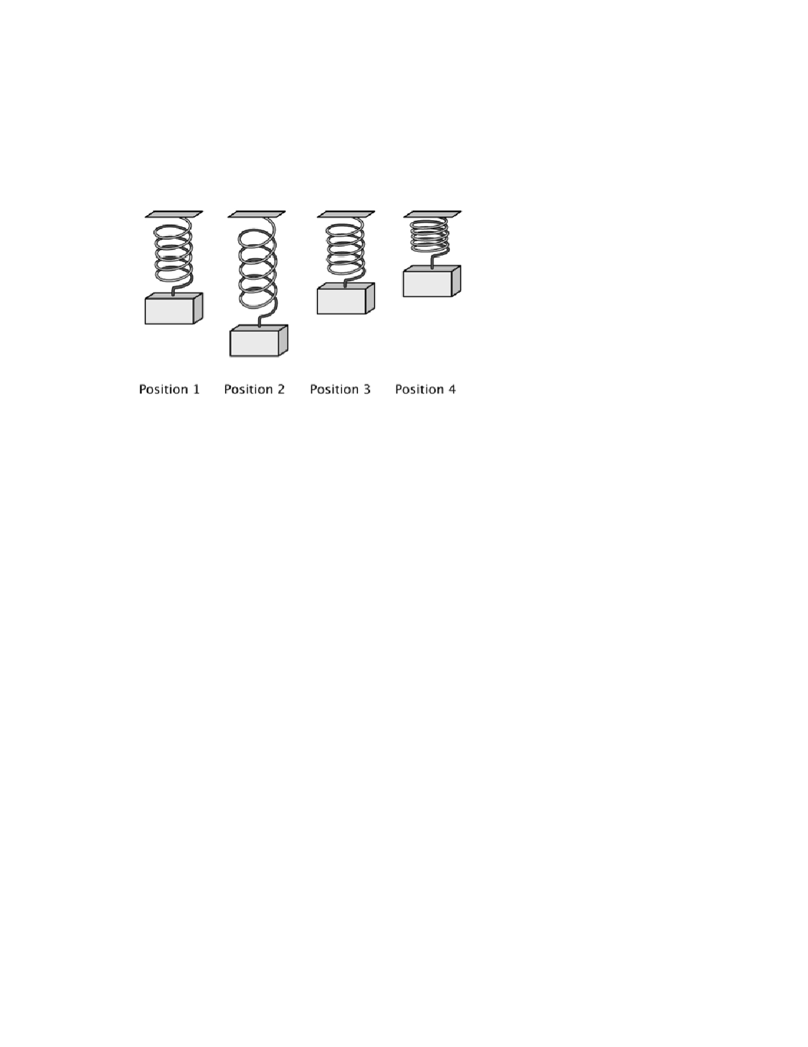
Name: ______________________ ID: A

____ 15. Kylie drew this illustration to show what happens when a weight on a spring is pulled
down and then released. Position 1 shows the spring at the start of the experiment.
Position 2 shows how it looked when the weight was pulled downward. Position 3
shows what happened when she released the spring. Position 4 shows the spring just before the weight started to fall back down.

At which point does the spring have the greatest amount of gravitational potential
energy?

A. Position 1

B. Position 2

C. Position 3

D. Position 4

____ 16. Which of these is an example of the conversion of gravitational potential energy into
kinetic energy?

A. a person running on a level track

B. an apple falling from a tree to the ground

C. a windup spring making a toy car move across the floor

D. a rubber band being stretched to twice its normal length

____ 17. Which unit is used to measure distance?
A. centimeters
B. grams
C. milliliters D. seconds

10

Name: ______________________ ID: A

____ 18. The arrows below represent the velocity of a car and a bus.

What does the length of each arrow represent?
A. direction B. location
C. speed D. velocity
____ 19. Pablo notices that ice cream begins to melt when left out at room temperature. What is
Pablo observing?
A. a physical change B. a chemical change C. a chemical reaction
D. the formation of a new substance
____ 20. Chemical changes result in new substances, but physical changes do not. Which
process is an example of a chemical change?

A. chopping a tree B. cooking a steak
C. making a cup of tea
D. drying clothes in the dryer

11

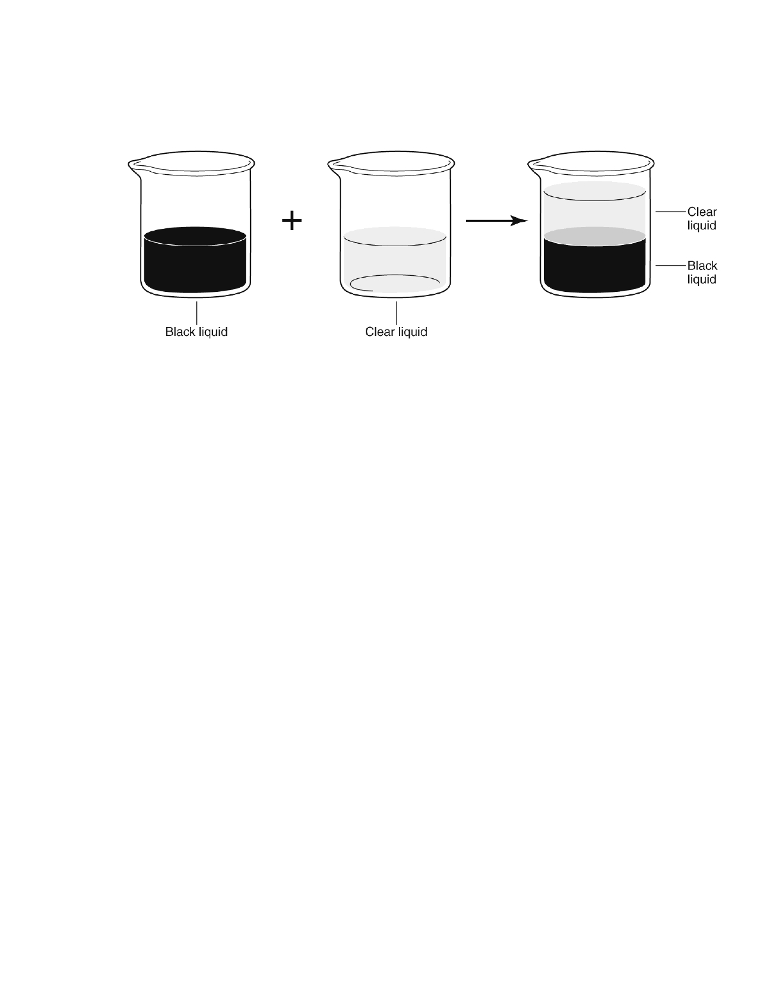
Name: ______________________ ID: A

____ 21. Kavish mixes a black liquid and a clear liquid. He knows the two liquids do not mix well.
Kavish allows the mixture to settle for 30 minutes.

Which of these statements is true?

A. The clear liquid is less dense than the black liquid. B. The clear liquid is less soluble than the black liquid. C. The clear liquid is less reactive than the black liquid. D. The clear liquid is less conductive than the black liquid.
____ 22. What term describes the state of matter in which the attractive forces between particles
are the greatest?
A. liquid B. solid C. gas
D. metal
____ 23. What is the name given to the lowest point of a wave?
A. crest
B. trough
C. amplitude
D. rest position
____ 24. Mei knows the wavelength and the frequency of a wave. How will she use this
information to calculate the speed of the wave? A. Add frequency and wavelength. B. Divide frequency by wavelength. C. Divide wavelength by frequency.
D. Multiply wavelength and frequency.

12

Name: ______________________ ID: A

____ 25. Suppose a mechanical wave is traveling through medium A. When the wave enters
medium B, it speeds up. Which of the following statements can be true about medium
A and medium B?

A. Medium A is a solid and medium B is a gas. B. Medium A is a liquid and medium B is a solid. C. Medium A is a gas and medium B is a vacuum. D. Medium A is a vacuum and medium B is a liquid.
____ 26. During a thunderstorm, Sanjay saw lightning and then heard thunder. 5 s later. What
would be different if the air had been warmer?

A. He would have seen the lightning and heard the thunder at the same
time.
B. He would have heard the thunder before seeing the lightning. C. He would have heard the thunder sooner. D. He would have heard the thunder later.
____ 27. Through which of these media do sound waves travel most slowly?
A. iron
B. wood C. water
D. cold air
____ 28. What do elements, compounds, and mixtures have in common?
A. They are all made up of atoms.
B. They are all made up of pure substances.
C. They can all be broken down by physical changes. D. They are all found on the periodic table.
____ 29. Assume water and other substances are mixed to form a solution, a suspension, and a
colloid. Which type of mixture contains the largest particles?
A. colloid
B. solution
C. suspension
D. All particles are the same size.
____ 30. One of the products of photosynthesis is the sugar glucose, represented by the
chemical formula C6H12O6. Which is true of glucose molecules?
A. Each molecule is chemically identical.
B. Each molecule contains a single nucleus surrounded by an electron
cloud.
C. Each molecule contains 6 hydrogen atoms and 12 oxygen atoms.
D. Each molecule is made up of glucose atoms joined by chemical bonds.

13

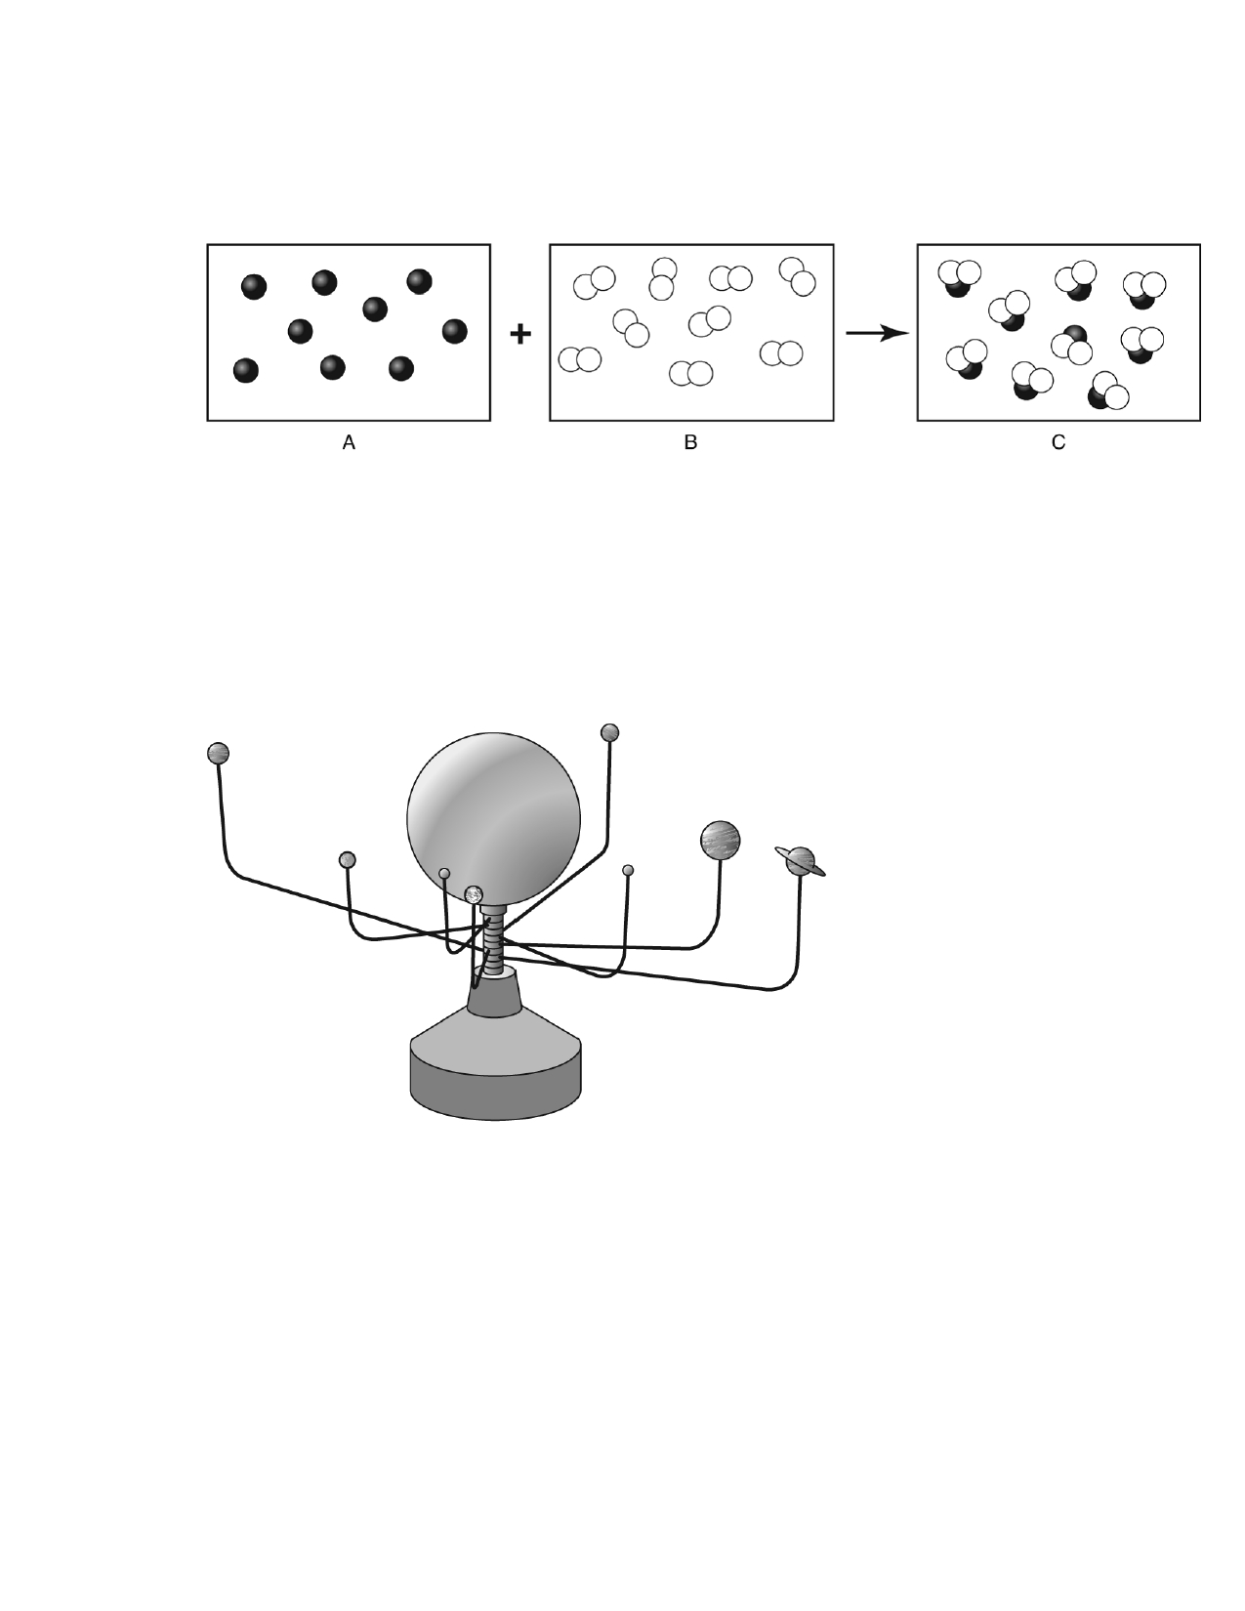
Name: ______________________ ID: A

____ 31. Reactants are the substances going into a chemical reaction. Products are the result of
the reaction. Both reactants and products are substances.

What TYPE OF SUBSTANCE is reactant B?
A. a nucleus B. a mixture
C. an element
D. a compound
____ 32. The picture shows a model of the solar system.

Which is a limitation of the model?

A. B. C. D.

It cannot show the relative sizes of each planet. It cannot show how the planets orbit the sun.
It does not show the gravitational force exerted by each planet.
It does not show the order of the planets, from closest to the sun to farthest from the sun.

14

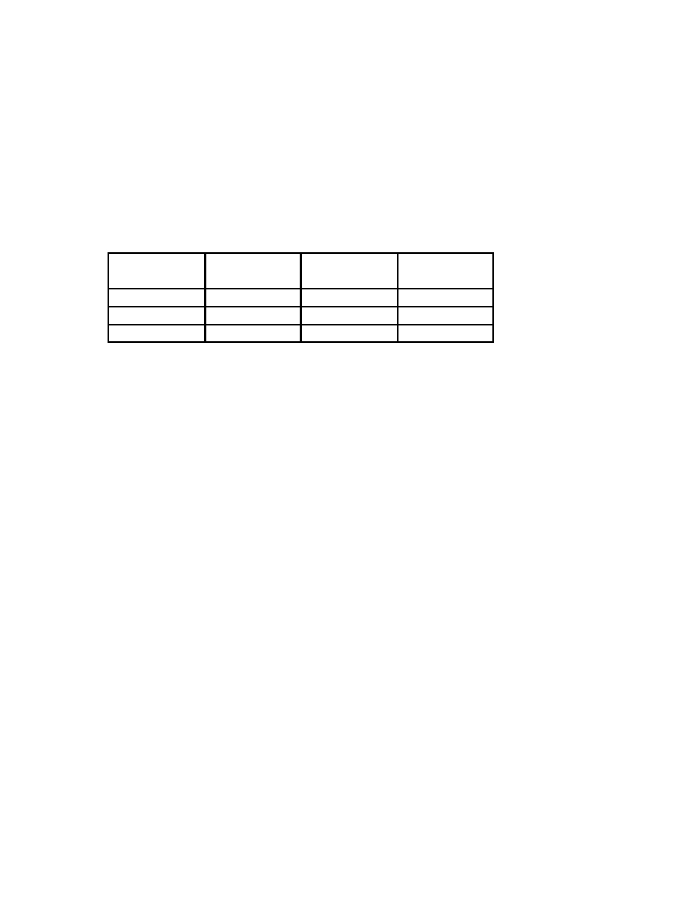
Name: ______________________ ID: A

____ 33. Shana was asked to conduct the following experiment.

Step 1: Label three test tubes 1, 2, and 3.
Step 2: Measure and record the mass of each test tube.
Step 3: Add a small amount of the unknown solid to each test tube and repeat step 2. Step 4: Heat each test tube over a flame for 3 minutes, then repeat step 2.

She needs to create a data table that records the data in the order in which she collects them. Here is part of Shana's data table.

Test tube Mass, empty ? ?
(g)
12
3

What HEADINGS should Shana list in place of the question marks?

A. Temperature before heating; Temperature after heating
B. Temperature before heating (°C); Temperature after heating (°C) C. Mass with solid before heating; Mass with solid after heating D. Mass with solid before heating (g); Mass with solid after heating (g)

15

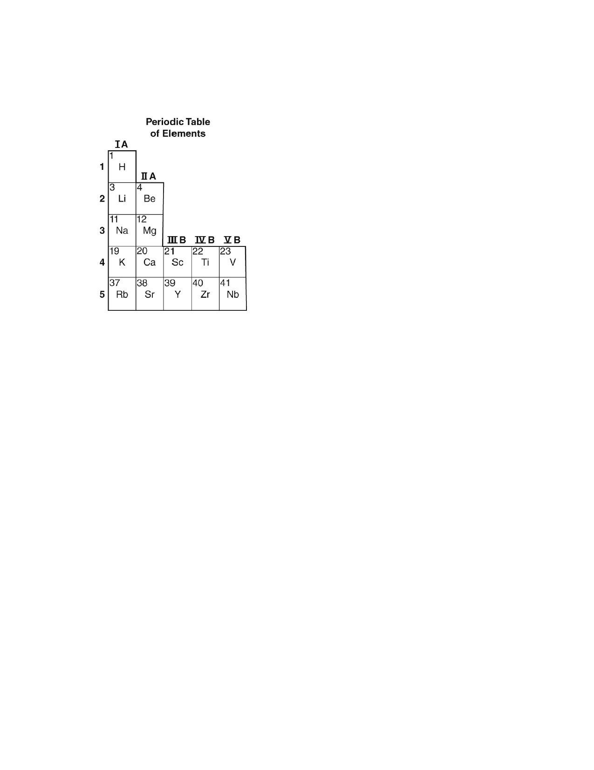
Name: ______________________ ID: A

____ 34. In the periodic table, elements with similar chemical properties are arranged in the
same column.

Which of these elements has properties most similar to those of magnesium (Mg)?

A. Be B. Na C. Sc D. Ti
____ 35. Although a scientific theory is well supported and widely accepted, what might cause it
to change?

A. new evidence B. a scientific law C. individual claims D. a scientific model
____ 36. Which of the following is the best description of a scientific theory?
A. an educated guess
B. a description of natural phenomena
C. a testable statement
D. a well-supported explanation

16

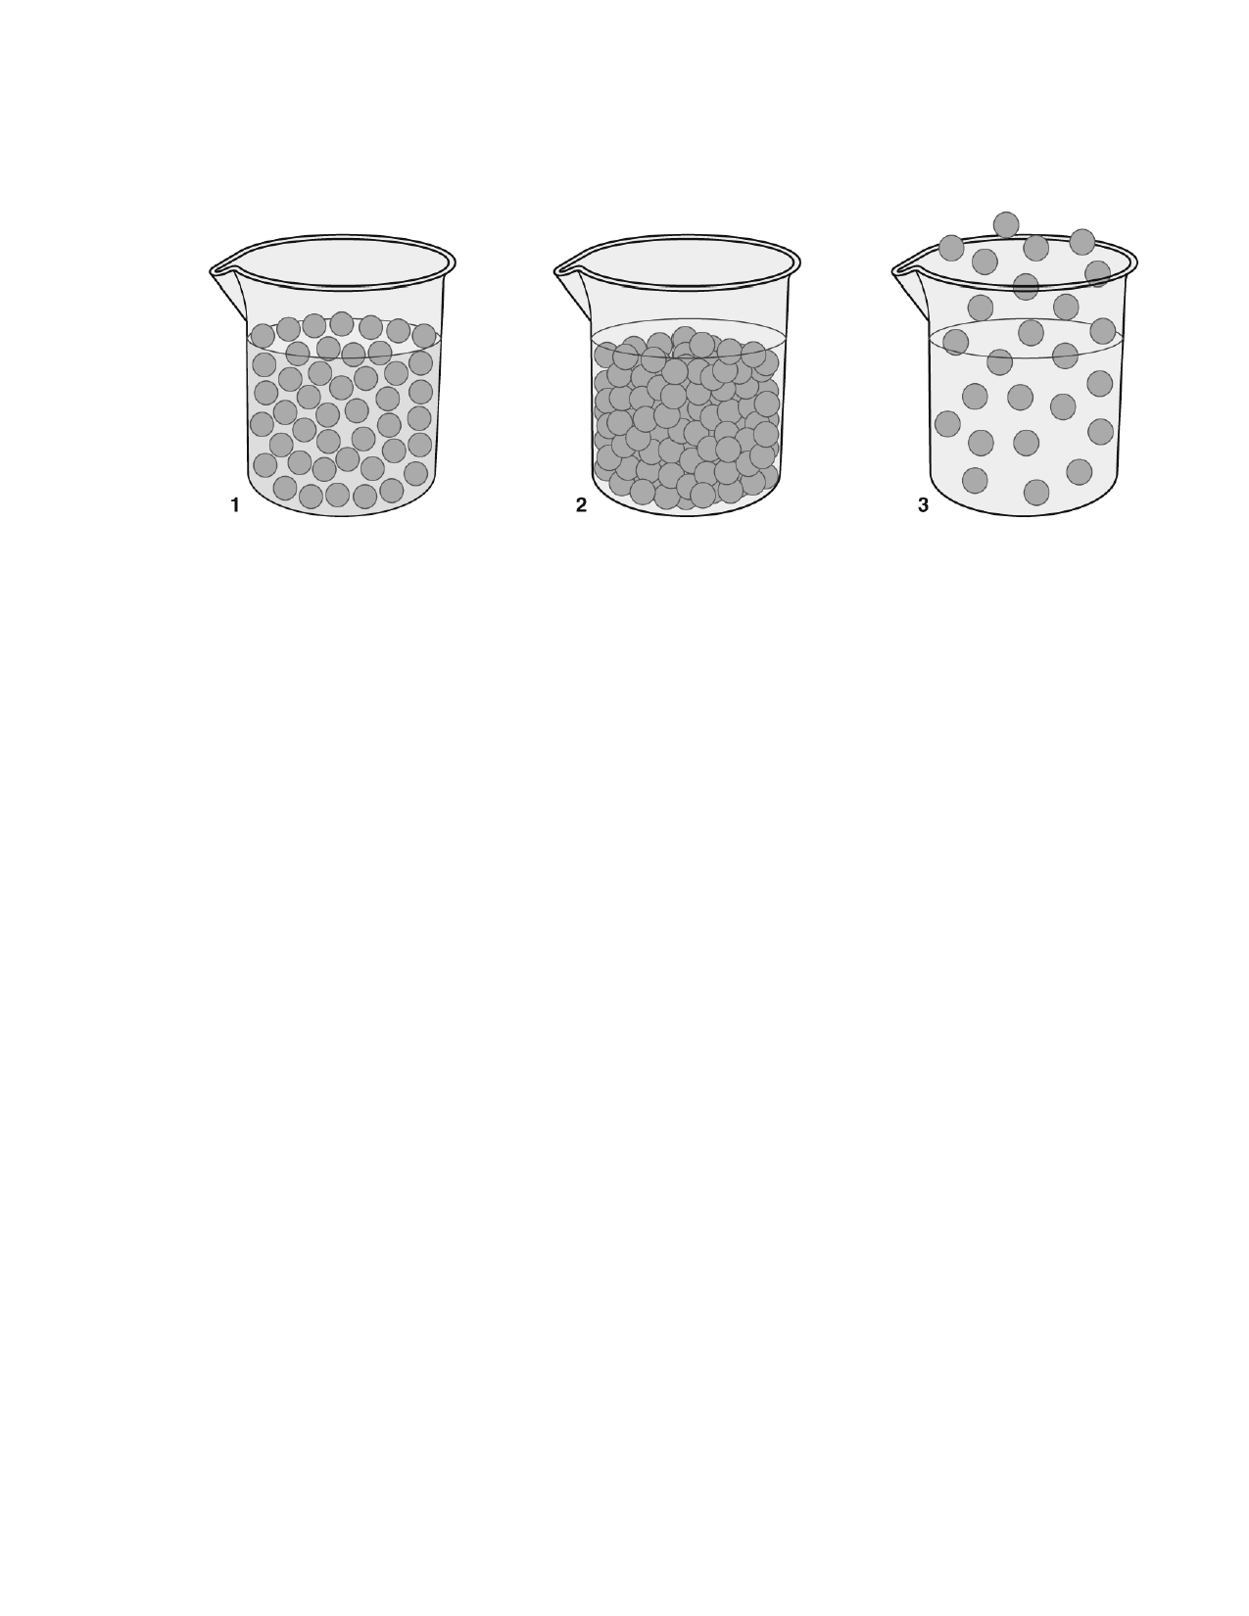
Name: ______________________ ID: A

____ 37. Tyson draws a model to show how the particles in a liquid appear.

Which model (or models) above could be Tyson's drawing of particles in a LIQUID?

A. model 1B. model 3
C. model 1 and model 2
D. model 1, model 2, and model 3
____ 38. In which state of matter are the particles able to move around one another?
A. gases only B. liquids only
C. gases and liquids only
D. gases, liquids, and solids
____ 39. Inez is making a model of a sugar crystal. She wants her model to show how the sugar
molecules move in the crystal. She is using plastic foam balls to represent the sugar
molecules. How should she put the plastic foam balls together to make her model?
A. glue them together
B. join them like beads on a string
C. connect them with stiff springs
D. place a few of them in a plastic bag

17

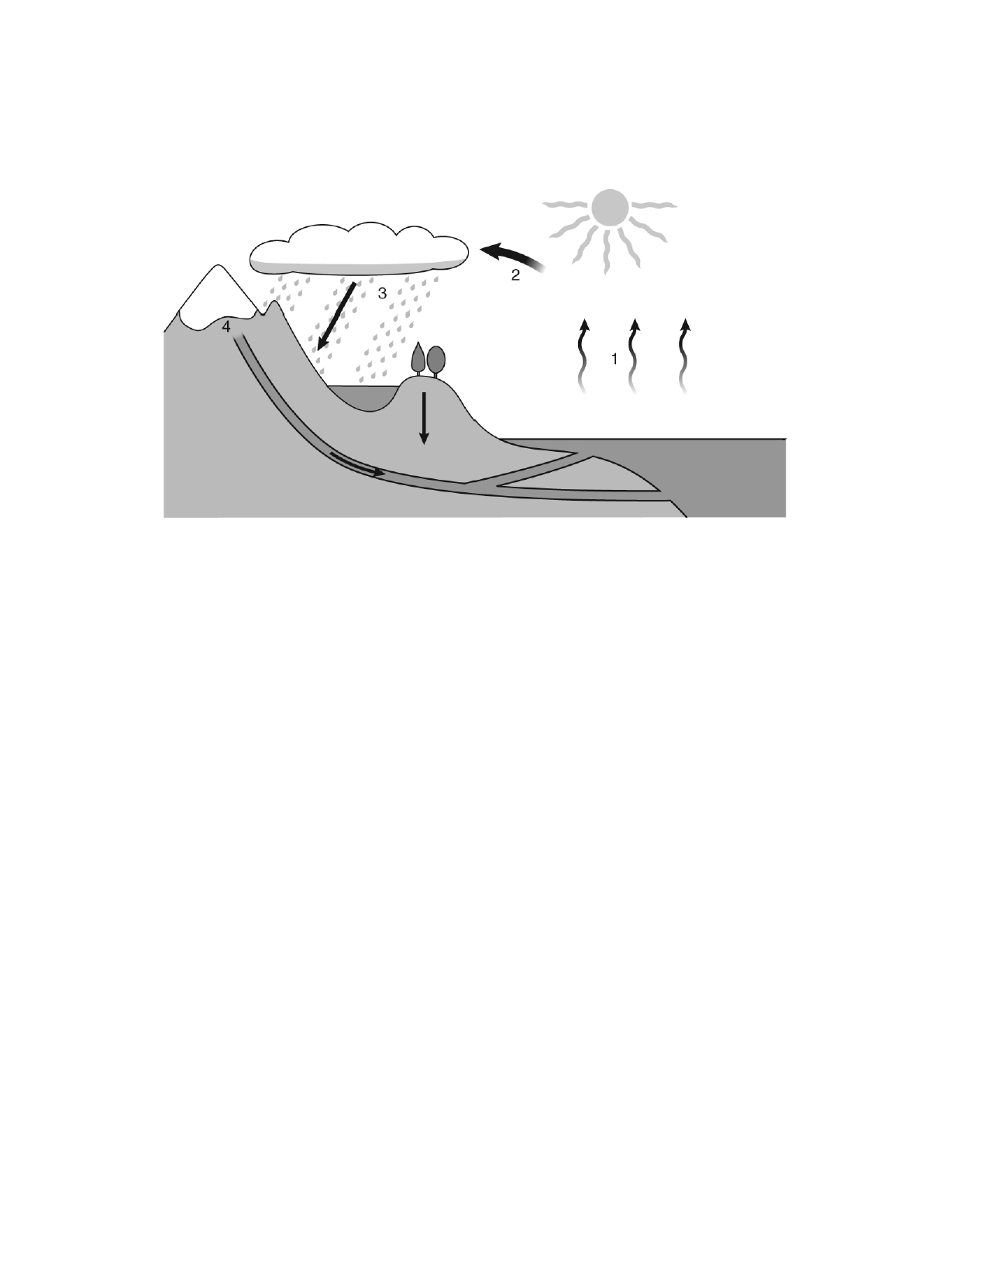
Name: ______________________ ID: A

____ 40. The diagram below shows the water cycle on Earth. In step 2, water vapor condenses
into water droplets to form clouds.

How does the mass of the water vapor compare to the mass of the water droplets it
forms?

A. B. C. D.

The mass of the water vapor is greater than the mass of the droplets. The mass of the water vapor is less than the mass of the droplets. The mass of the water vapor equals the mass of the droplets.
The masses of the water vapor and the droplets depend on the temperature.

____ 41. Which state of matter will take both the volume and shape of the container that holds it?
A. gas B. ice
C. liquid D. solid
____ 42. The kinetic theory of matter states that matter is made up of tiny particles that are in
constant motion. The kinetic theory of matter is most useful in describing which of the
following?

A. the relationship between mass and weight B. the relationship between a balance and a scale C. the relationship between solids, liquids, and gases D. the relationship between mass, volume, and density

18

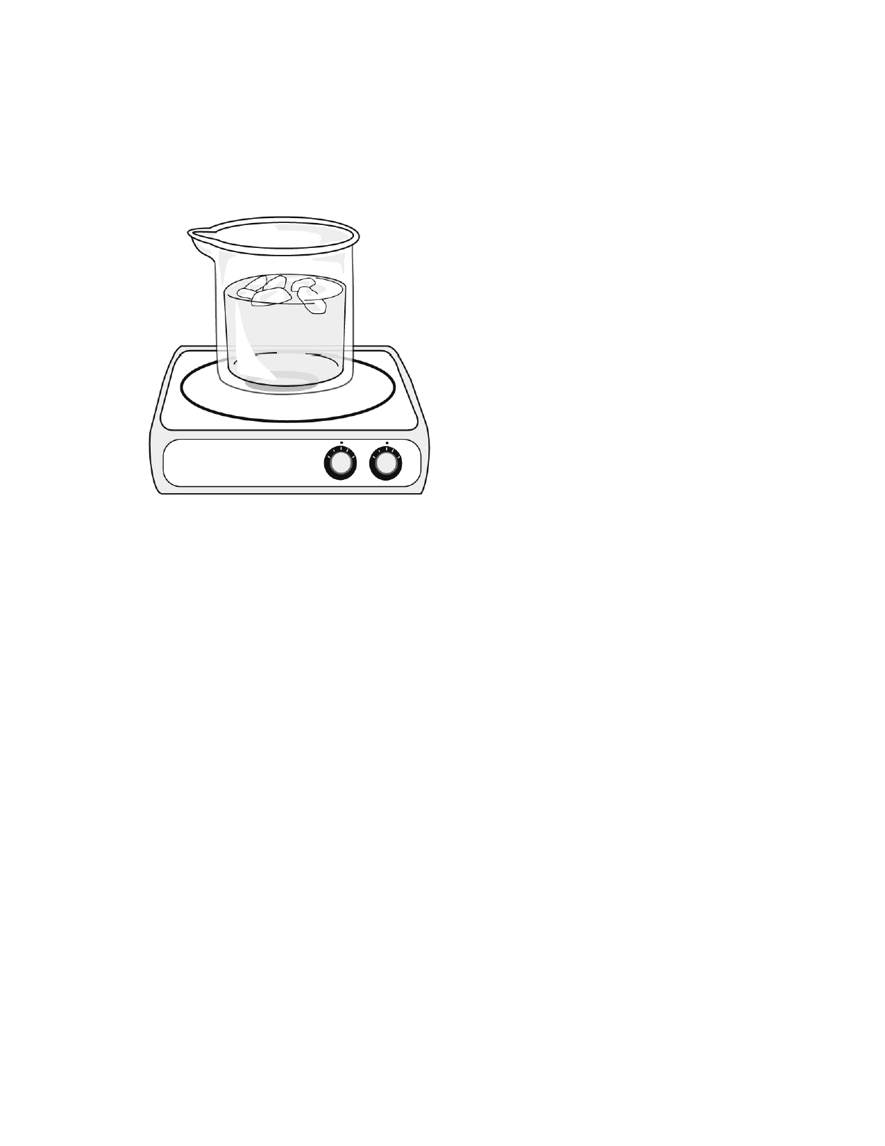
Name: ______________________ ID: A

____ 43. Reggie puts a beaker of ice and water on a hot plate, and the ice slowly begins to melt
as shown in figure below. After a few minutes, only liquid water is in the beaker.
Eventually, the water becomes hot and boils. The liquid water changes to water vapor, which is a gas.

In what way is the ice different from the water vapor that forms after the water begins to
boil?
A. The ice has a lower boiling point. B. The vapor particles move slower. C. The ice has a higher temperature.
D. The vapor particles have more energy.

19

Name: ______________________ ID: A

____ 44. The diagram below shows a model of an atom.

Which label points to the nucleus?

A. AB. BC. CD. D
____ 45. Calcium is an element. What is the smallest particle of calcium that has the same
chemical properties of calcium?

A. an atom of calcium
B. a proton from a calcium atom C. an electron from a calcium atom D. a molecule that contains calcium
____ 46. Four of the types of electromagnetic waves are microwaves, radio waves, infrared
waves, and visible light waves. Which of these waves has the most energy?
A. microwaves B. radio waves
C. infrared waves
D. visible light waves

20

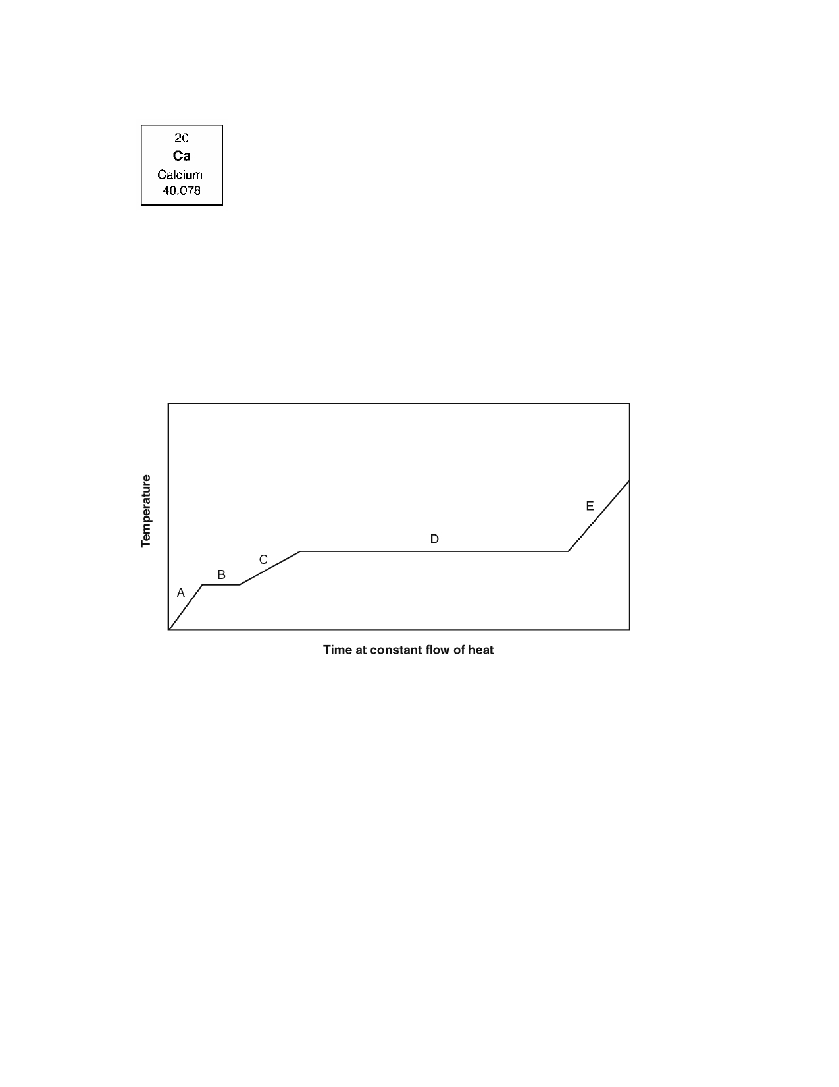
Name: ______________________ ID: A

____ 47. The entry for one element in the periodic table is shown below.

What is the element's chemical symbol?

A. 20
B. 40.078 C. Ca
D. Calcium
____ 48. Ashley warms a pure, solid substance. She graphs the changes in temperature as
shown in the figure below.

Which process takes place during segment D?

A. melting
B. evaporation
C. increase in temperature of a gas D. increase in temperature of a liquid

21

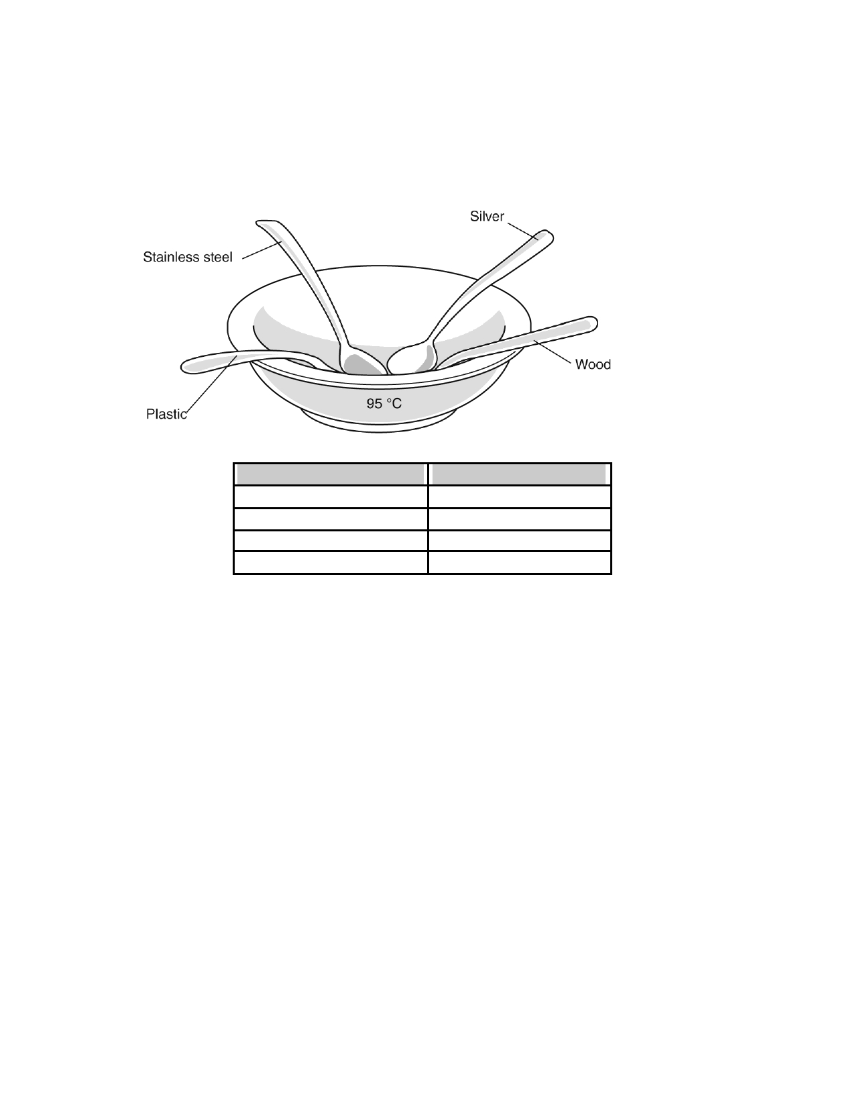
Name: ______________________ ID: A

____ 49. Kishawn performs the experiment illustrated in the figure to find out how energy flows
through different materials. He warms some water to 95 °C and pours it into a bowl.
Then he places spoons made of four different materials into the bowl with their handles
sticking out of the water. After 2 min, he touches each spoon handle with his fingers and records his observations.

Material
plastic
stainless steel
silver
wood

Observation slightly warm
hot
very hot
not warm

Which conclusion can Kishawn draw based on his observations?

A. B. C. D.

Plastic is a better conductor than steel is. Wood is a better radiator than silver is.
There is more convection in the silver spoon than in the plastic spoon. The silver spoon and stainless steel spoon are better conductors than the wooden spoon and plastic spoon are.

____ 50. What is true of all transverse waves and longitudinal waves?

A. They must travel through a medium. B. They can travel through empty space.
C. They move energy from one place to another. D. They move particles from one place to another.

22

Name: ______________________ ID: A

Short Answer

1. If you know the volume and density of an object, explain how you can determine its
mass.

2. Identify whether each of these statements describes a physical change or a chemical
change.

a. Fireworks light up the night sky.

b. A metal rod bends under pressure.

c. An apple changes color as it ripens.

d. A piece of wood gets smoother when sanded.

e. A lawn mower cuts off the tops of blades of grass.

f. Vinegar and baking soda bubble when mixed together.

g. Ice cream melts when left on the kitchen counter.

h. Bread cannot be turned back into dough after baking.

i. Iron filings are separated from sand using a magnet.

j. A rotting banana left in a closed container produces warmth.

23

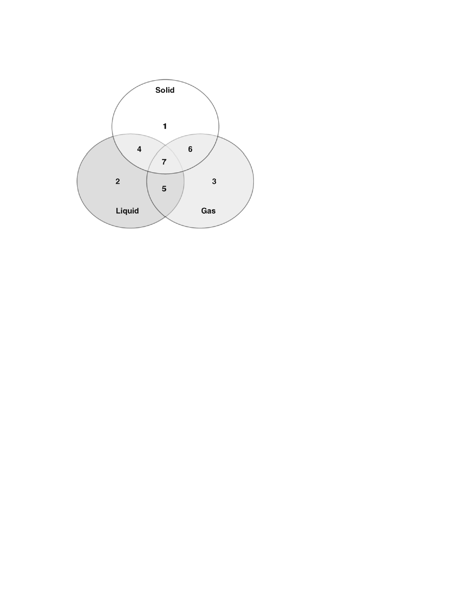
Name: ______________________ ID: A

3. The Venn diagram below compares the properties of solids, liquids, and gases.

List the properties of gases that would be in position 3 and position 5, and explain why gases have these properties.

24

