Assignment Sheet 7th Grade
January 11, 2016

Objective: Today I am classifying unicellular and multicellular organisms as producers, consumers, and decomposers by the roles they serve in an ecosystem. I am also organizing parts of an energy pyramid (trophic levels) so that I understand the flow of energy in ecosystem. I am examining how living things adapt to their environment. Finally, I am describing the beneficial and harmful activities of organisms within an ecosystem so that I understand the impact these activities have on the entire food chain or food web.

____Complete Kahoot it.com in class. Record scores below.

____Sheppard Software Food Chains: Complete the “food chain game”, “Parts of a Food Chain”, and “Photosynthesis/Herbivores”. Summarize what you learned from this activity below. Summarize learning in at least 4 sentences.

_____Notes: PowerPoint on my Weebly page entitled: Food Chain/Web/Energy Pyramid (trophic

______Vocabulary: It’s in the Cards (after completing organizer place on page 53 in your notebook) Population, Producer,Consumer, Decomposer, Food chain, Food Web, Energy Pyramid, Ecosystem, Abiotic Factors, Biotic Factors, Biome, Secondary Consumer, Primary Consumer, Tertiary Consumer, Classify

_____Video: Rap Food Chain/Food Web, Study Jam: Food Chains, Food Webs/ Summarize what you learned in the space below. Remember to use at least 4 sentences. See my Weebly page/Study Jam
__
_____Use vocabulary words to build a concept web…see examples on the bulletin board. Connect each term to other terms. Each link or arrow connecting terms should include a description of how interconnected terms are related. Go to my Weebly page and watch first 5 minutes on how to create a concept web. Note: webs can be created as a Word document or using paper and pencil.
____Food Chain/Food Web/Energy Pyramid (trophic level) Project. Go to my Weebly page and click on <Project> for details related to this project.
____Interactive Food Chain/Web/Trophic Level Activity (Teacher-led) (Tuesday)
____Game Task Card. Create an energy pyramid below with organisms with organisms on the task card.
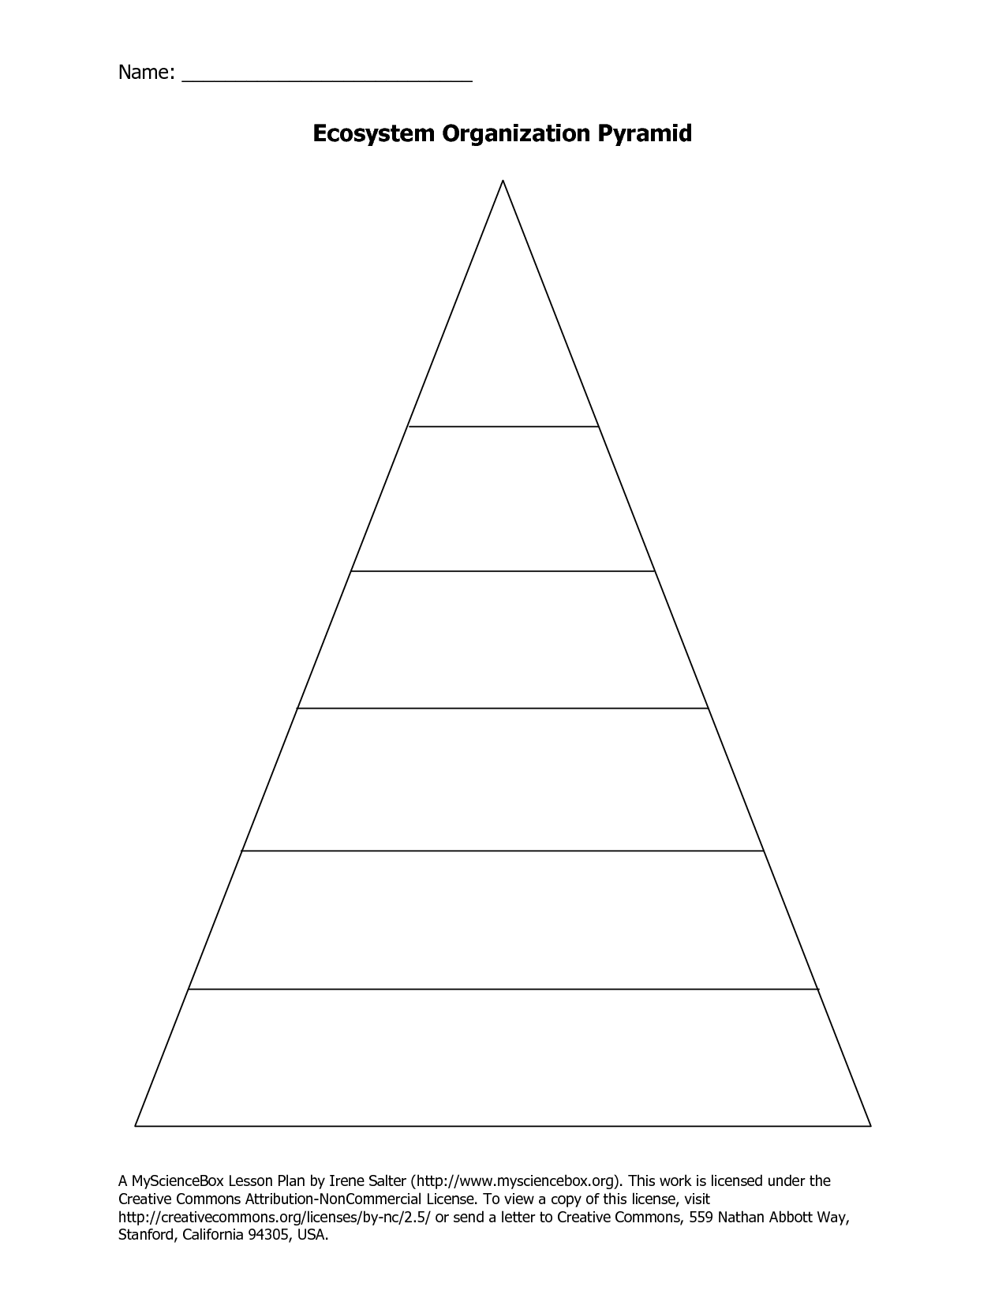

_____( Wednesday) Review Kahoot .com (teacher-led) / Interactive Food Chain Game: http://interactivesites.weebly.com/food-chains.html (Create a poster or type an essay about the following)
http://coolclassroom.org/cool_windows/home.html
____Review Note: Take Practice Food Web/Chain/Trophic Level Test
____Megladon Video: How did it survive?
____Notes: Adaption. PowerPoint (Weebly)
____Poster Project Create Adaption Poster:Given an organism, research how this organism adapts in environment. Present your poster to the class.
____Explain the effects on the food chain if one of the following happens within the food web:
One of the links of the food chain is interrupted
Drought Insecticide Predators Invasive species
http://classroom.misd.org/users/0210/Energy%20Flow%20Through%20Living%20Systems%207.5C/Food%20Web%20Food%20Chain%20Project.pdf

